Introduction
This report looks at how United Airlines flights departing from New York City in 2013 performed compared to their scheduled times. The focus is on flight net gain, which measures how much time a flight recovered during the journey after leaving late. Net gain is defined as departure delay minus arrival delay: a positive value means the flight made up time, while a negative value means the delay worsened.
In addition to total gain, we also consider gain per hour, which adjusts for flight length and allows fair comparisons between shorter and longer flights. By examining these measures, the report explores whether flights that left late were able to recover time, how gains varied across the most common destinations, and whether flight length influenced the ability to make up time. The findings are shared in plain language, with simple graphs and tables, so that the patterns and differences can be understood without any technical background.

Methodology
This study uses the nycflights13 dataset, which contains records of all flights that departed from New York City airports (JFK, LGA, and EWR) in 2013, focusing only on United Airlines flights. The dataset has null values, which we ignored in our analysis so that calculations were based only on complete information. Flights missing departure delay, arrival delay, or flight duration were excluded, since these details are necessary to measure flight gain.
To capture how much time flights recovered after leaving late, we created a new variable called net gain, defined as departure delay minus arrival delay, where positive values mean the flight made up time during the journey and negative values mean the delay worsened. We also calculated gain per hour by dividing net gain by the flight’s duration in hours, allowing fair comparisons between shorter and longer flights. Flights were grouped into categories such as on time (departure delay equal to or less than zero), late (departure delay greater than zero), severely late (departure delay greater than thirty minutes), and short or long flights based on typical flight duration. The analysis combined graphs, tables, confidence intervals, and hypothesis tests to show overall patterns and to check whether differences between groups were meaningful or simply due to chance.

United Airlines Flight Delay Analysis
- Does the average gain differ for flights that departed late versus those that did not? What about for flights that departed more than 30 minutes late?

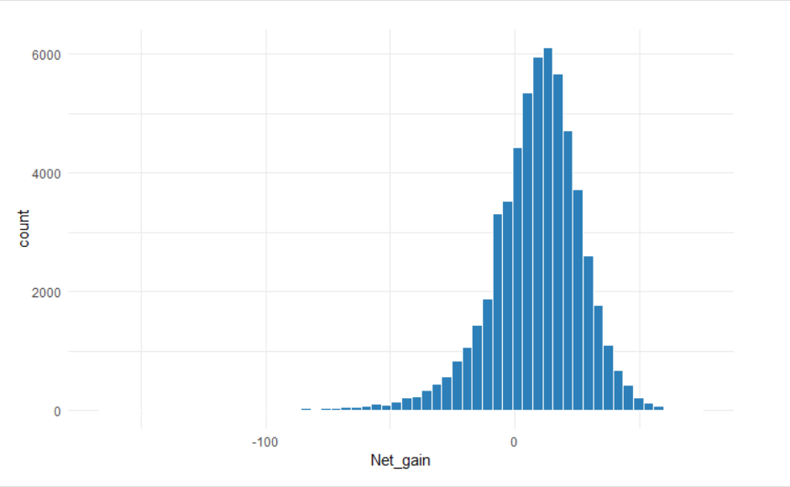
The histogram shows how much time United Airlines flights recovered during the flight, based on a variable called Net gain. Each bar represents how many flights had a certain amount of gain or loss. Most flights gained a small amount of time, with the highest bar centered just above zero. This means that many flights arrived slightly earlier than their departure delay would suggest. The shape of the chart is roughly symmetrical, with fewer flights showing very large gains or losses. Overall, the distribution looks balanced, with a peak near zero and a gradual tapering on both sides.

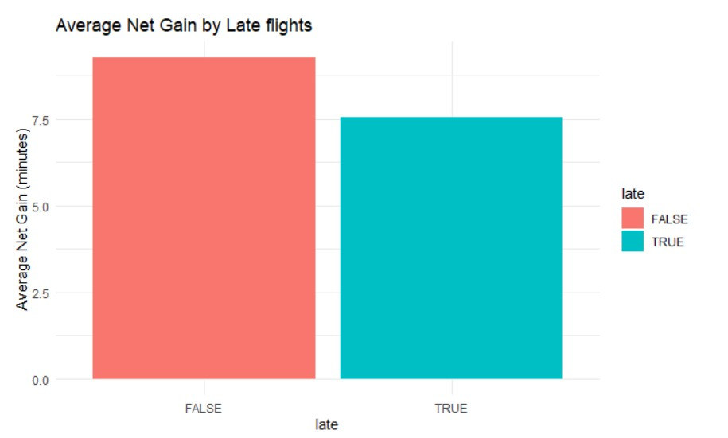
This chart compares the average net gain between flights that departed late and those that did not. Each bar shows the average number of minutes gained during the flight. Flights that were not late (shown in red) had a higher average gain—just over 9 minutes—while flights that were late (shown in blue) gained slightly less, around 7.5 minutes. This suggests that even flights that left on time often arrived earlier than expected, and that late departures still recovered sometimes, but not as much on average.

Late | Average Net Gain | N
False | 9.27 | 30657
True | 7.54 | 27125

For UA flights, those that departed late (dep_delay > 0) had an average net gain of 7.54 minutes (SD = 20.86, n = 27,125), while flights that did not depart late had an average net gain of 9.27 minutes (SD = 17.28, n = 30,657). This indicates that on-time flights slightly recovered more time in the air on average, though late flights showed greater variability.

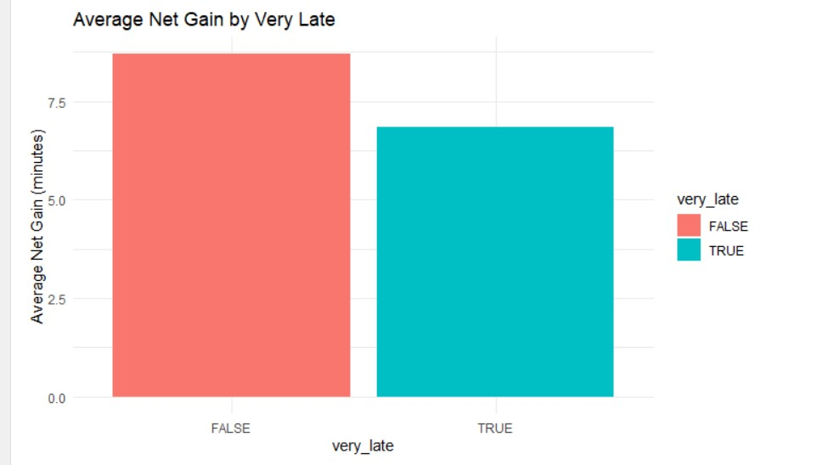
This chart compares the average amount of time flights recovered during the journey based on whether they were very late or not. Flights that were not very late (shown in red) gained about 7.8 minutes on average, while flights that were very late (shown in blue) gained slightly less—around 6.5 minutes. This suggests that even severely delayed flights still make up some time, but not as much as those with smaller delays.

Very_late | Average Net Gain | N
False | 8.7 | 50232
True | 6.86 | 7550

For UA flights, those delayed more than 30 minutes had an average net gain of 6.86 minutes (SD = 24.43, n = 7,550), while flights delayed 30 minutes or less had an average net gain of 8.70 minutes (SD = 18.11, n = 50,232). Very late flights gained slightly less time on average, but the variability was higher.
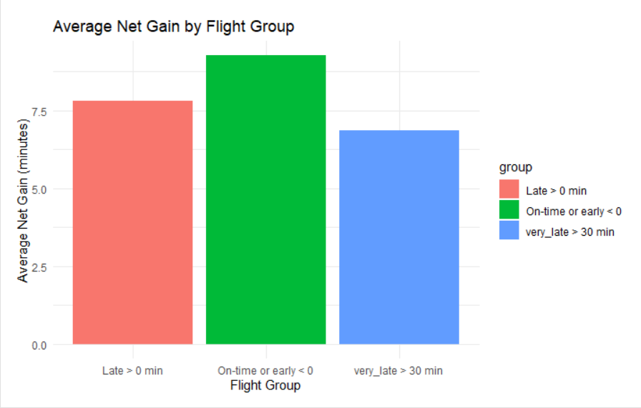

This chart compares how much time flights recovered during the journey, based on three different departure categories. Flights that were on time or early (shown in green) had the highest average gain, just over 8 minutes. Flights that left late (shown in red) gained slightly less time, and flights that were very late (shown in blue, meaning they left more than 30 minutes late) had the lowest average gain, just above 6 minutes. This suggests that while all groups recovered some time, flights with smaller delays or on-time flights tended to make up more minutes on average than those with longer delays.

- Five most common UA destination airports

The top 5 destinations from NYC on United Airlines are Chicago-O’Hare (ORD), Houston-Bush (IAH), San Francisco (SFO), Los Angeles (LAX), and Denver (DEN).

Airport | ORD | IAH | SFO | LAX | DEN
Flights | 6984 | 6924 | 6819 | 5823 | 3796

Interestingly, Denver holds the fifth-highest position, but, the number of flights from position 4 (LAX) to Denver drops at a more significant margin than what was observed from positions 1-4.

Average gain per airport
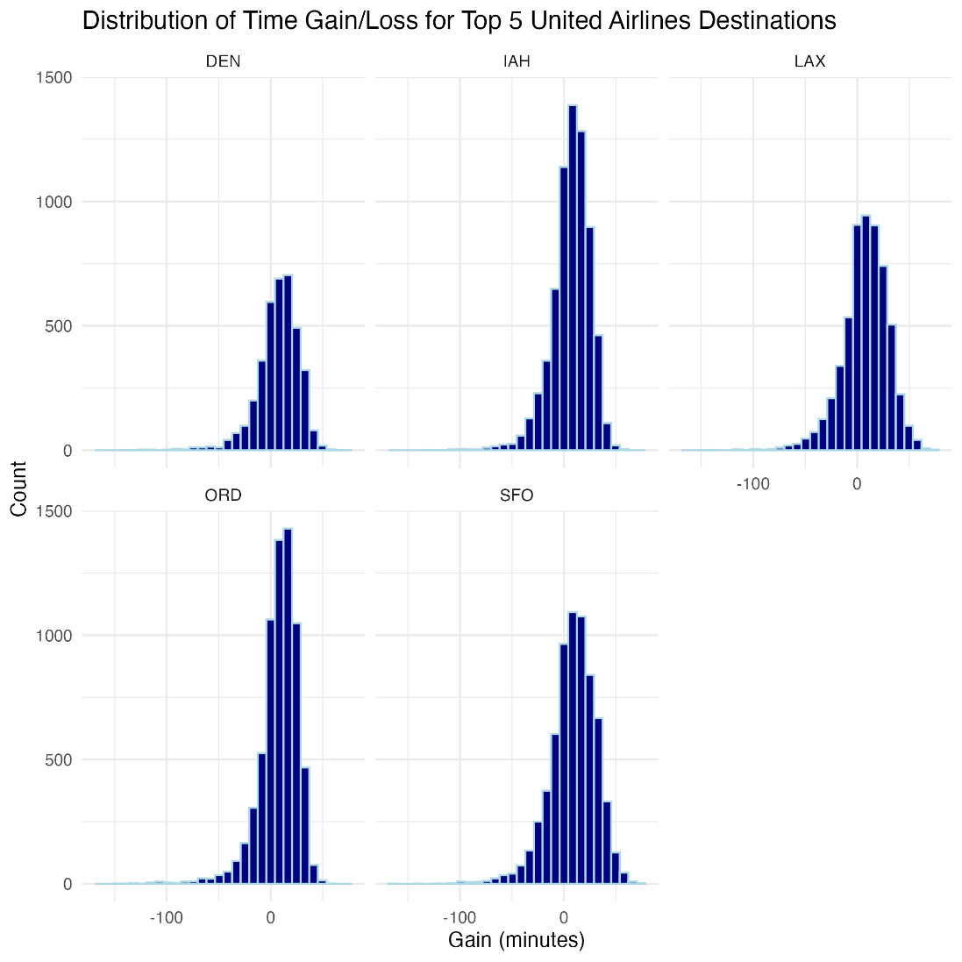
All five destinations show distributions centered just above zero, meaning United flights typically gain a little time on average. DEN and SFO have tighter, more compact shapes, suggesting more consistent performance. IAH and LAX show slightly wider spreads, with more flights losing larger chunks of time. ORD has the most pronounced left tail, indicating the biggest time losses overall. Across all five airports, the average gain is negative, so none of these routes routinely make up time in the air.
Confidence interval and bootstrap permutation give intervals fully above zero.
Because the 95% bootstrap confidence intervals for all five airports are entirely above 0, we reject the null hypothesis for each destination. There is strong statistical evidence that United flights to DEN, IAH, LAX, ORD, and SFO consistently gain time in the air, reducing their departure delays by roughly 7–9 minutes on average.
In conclusion, UA flights typically reduce their delay by about 7–9 minutes while flying to their top 5 destinations.

- Gain relative to the duration of the flight

The gain per hour is calculated by dividing the total gain(departure delay-arrival delay) by the duration(airtime) in hours of each flight.

Gain Per Hour for flights that departed late versus that departed on-time

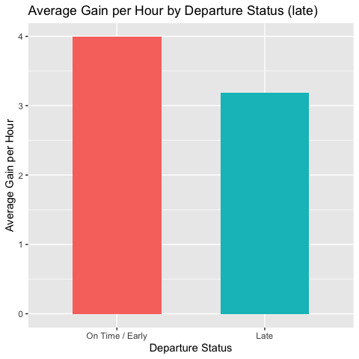

Summary table for average gain per hour for flights that departed late.
late | count | mean_gph* | median_gph* | sd_gph* | min_gph* | max_gph*
FALSE | 30657 | 3.99 | 3.33 | 7.74 | -106.23 | 56.47
TRUE | 27125 | 3.18 | 3.01 | 9.24 | -138.95 | 68.82
*gph(gain per hour)

The results indicate a clear difference in average time recovery between flights that departed on time and those that departed late. Flights that departed on time or early achieved a higher mean gain per hour (3.99 minutes) compared with flights that departed late (3.18 minutes). Although both groups show substantial variability as reflected in their relatively large standard deviations, the consistent difference in mean values suggests that late-departing flights generally recover with less lost time during flight.
Late-departing flights show a wider spread between their minimum and maximum gain values, which means they are less consistent in how much time they can make up. Overall, the results suggest that even though flights try to recover time while in the air, starting late limits how much time they can realistically regain. This is likely because of factors such as air-traffic control rules, crowded routes, or other operational constraints that prevent pilots from speeding up as much as they might want to.
To compare the difference in gain per hour between the late and early/on time departure status, we conducted statistical tests. The result of the test is shown below:
Description | Results
p-value | < 0.05
Confidence interval | (0.666,0.946)
Mean-late | 3.99
Mean-on time/early | 3.18

The 95% confidence interval for the true difference in mean gain per hour between on-time departures and late departures is (0.666, 0.946). Because this interval does not include zero, it provides strong evidence of a statistically significant difference between the two groups.
There is a significant difference in average gain per hour between flights that depart on time and those that depart late. The positive mean difference, combined with a confidence interval entirely above zero, indicates that on-time flights consistently gain more time per hour than late departures. This suggests that departing late limits a flight’s ability to recover time during the journey.
Gain Per Hour for flights that departed very late versus that departed on-time

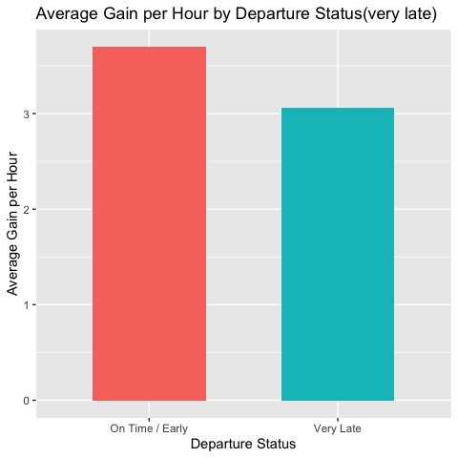

Summary table for average gain per hour for flights that departed very late.
very_late | count | mean_gph | median_gph | sd_gph | min_gph | max_gph
FALSE | 50232 | 3.69 | 3.18 | 8.06 | -118.33 | 68.82
TRUE | 7550 | 3.06 | 3.33 | 10.89 | -138.95 | 60.00
*gph(gain per hour)

The average gain per hour is lower for flights that departed very late compared to those that departed on time or early. On-time flights gained an average of 3.69 minutes per hour, whereas very late flights gained only 3.06 minutes per hour. Although both groups show substantial variability, the difference in their mean values suggests that flights departing very late have reduced ability to make up time during flight.
The larger standard deviation and wider range among very late departures indicate higher inconsistency in how much time they can recover. This suggests that once a flight is significantly delayed at departure, operational constraints such as air-traffic control limits, congestion, or routing restrictions likely limit the extent of time recovery available in the air.

To compare the difference in gain per hour between the very late and early/on time departure status, we conducted statistical tests. The result of the test is shown below:
Description | Results
p-value | < 0.05
Confidence interval | (0.375,0.886)
Mean-very late | 3.69
Mean-on time/early | 3.06

The 95% confidence interval for the true difference in mean gain per hour between on-time departures and very late departures is (0.375,0.886). Because this interval does not include zero, it provides strong evidence of a statistically significant difference between the two groups.
There is a significant difference in average gain per hour between flights that depart on time and those that depart very late. The positive mean difference, combined with a confidence interval entirely above zero, indicates that on-time flights consistently gain more time per hour than very late departures. This suggests that departing very late limits a flight’s ability to recover time during the journey.

- Average gain per hour for longer flights versus shorter flights

Flights with an airtime less than or equal to the median airtime of the dataset were categorized as Short, whereas those exceeding the median were labeled Long.

Flight Length | Count
Long | 28736
Short | 29046

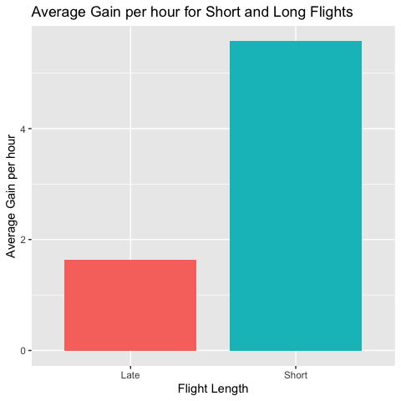

The graph shows that the average gain per hour is very high for short flights compared to that of long flights. To compare the difference between these two groups, we conducted statistical tests. The results of the tests is shown below:

Description | Results
p-value | < 0.05
Confidence interval | (-0.408, -0.3811)
Mean-short | 5.57
Mean-long | 1.63

The test result was highly significant providing strong evidence that the mean gain per hour differs between short and long groups.
The estimated mean gain per hour for short flights was 5.57 minutes, whereas long flights gained only 1.63 minutes on average. The 95% confidence interval for the true difference in means (Long – Short) ranged from –4.08 to –3.81, which does not include zero. This confirms a statistically significant and meaningful difference between the groups.
Short flights make up significantly more time per hour than long flights. Because gain per hour measures how much delay a flight recovers relative to its airtime, these results suggest that shorter routes provide greater opportunity for time recovery, while longer flights recover considerably less time relative to flight duration. This may reflect operational limitations on longer routes, such as air-traffic constraints or reduced flexibility to accelerate over long distances.

Discussion
The overall findings from this study show that United Airlines flights departing from New York City in 2013 often recovered some time in the air, but the amount of recovery depended on how late the flight left and how long the journey was. Flights that departed on time or early gained the most minutes overall, while flights that left very late gained the least. Short flights tended to recover more minutes per hour than long flights, suggesting that shorter routes provide more flexibility for pilots to make up time. Across the busiest destinations, the routes consistently made up a margin of their lost time, and most showed small average losses.
The key takeaway is that keeping departure delays small is important. Once a flight leaves very late, it is unlikely to fully recover, even if some time is made up during the journey. Shorter flights provide more opportunity for recovery, but longer flights are more constrained by air-traffic rules and operational limits.
Future follow-up work could expand this analysis in several useful directions. Comparing United Airlines with other carriers would show whether these patterns are unique or industry-wide. Examining external factors such as weather, airport congestion, or aircraft type could reveal why some flights recover more time than others. Looking at more recent years, it would show whether operational changes or new technologies have improved airlines’ ability to make up time. Finally, connecting these results to passenger outcomes such as missed connections or customer satisfaction would help translate the findings into real-world impact.

